**Denagene Tajhiz Company**

**Biotechnology Lab Equipment manufacturer and designer**

Horizontal Electrophoresis

User Guide

Thanks for choosing the Denagene Tajhiz Company’s Horizontal Electrophoresis. This operation manual describes the function of the instrument. To ensure you can correctly operate the instrument, please read the manual carefully before using it. Please keep this manual properly for later use if you encounter any difficulty. The first time opening the packing, please check the instrument and appendix with the packing list. If anything does not match the packing list, don't hesitate to get in touch with us.

This manual is a valuable resource for all users of our products, whether you are a seasoned professional or just starting your scientific journey. It has been meticulously crafted to ensure that you clearly understand the features, functionality, and proper usage of our laboratory equipment.

Within these pages, you will find detailed instructions, diagrams, and troubleshooting guides that will assist you in harnessing the full potential of our products. We have taken great care to ensure that the content is organized logically, making it easy for you to navigate through the manual and locate the information you need quickly.

Moreover, this manual is a living document that reflects our ongoing commitment to excellence. As we continue to develop and improve our product offerings, we will provide updates and revisions to this manual to ensure that you always have the most up-to-date information at your fingertips.

Reproduction in any form, whether print or electronic, without written permission from Denagene Tajhiz Company, is strictly prohibited.

**Content**

**Introduction**

**Safety Information**

**Maintenance**

**Technical Specification**

**Horizontal Electrophoresis System Parts and Accessories**

**Agarose Gel Characteristics**

**Factors Influencing Nucleic Acid Migration in the Gel**

**Anomalous Migration**

**DNA Migration and Separation Mechanism**

**Electrophoresis Procedure**

**Preparation of the Gel**

**Loading the Samples**

**Initiating Electrophoresis**

**Staining and Visualization**

**Buffers**

**Applications**

**Problems with DNA Electrophoresis and Possible Causes**

**Gel Cast Instruction Use**

**The operation mode of the Apparatus**

Introduction

Agarose gel electrophoresis is a type of gel electrophoresis used in the fields of biochemistry, genetics, and other subgroups of cellular and molecular sciences for the separation of various DNA, RNA, or protein sequences. It utilizes agarose gel as a medium created within a framework. Typically, the separation of biological molecules occurs by applying an electric field to this medium. Agarose gels are easily formed and are the primary choice for separating various DNA types in laboratory experiments. The separated DNA can be visualized by staining and observed under suitable light. Previously, ethidium bromide was used for visualizing DNA bands under UV light. However, today, various high-quality and less mutagenic dyes compared to Ethidium Bromide are available in the market, which can be visualized with visible light.

Agarose gels can be easily prepared using an appropriate gel casting system. Denagene Tajhiz’s electrophoresis systems are designed to ensure high-quality performance for years of use.

**Safety Instruction**

* Before using the product, thoroughly read and understand this manual to ensure the correct use.
* Denagene Tajhiz Electrophoresis Systems are designed with maximum user safety.
* Before any use, check that interface cables, probe connectors, tank chamber, and power supply are in perfect working condition.
* For high-voltage applications, use power supplies with high safety standards. The DGT-UNIVERSAL power supply model from Denagene Tajhiz Company Electrophoresis Systems is recommended
* In case of any unusual use or modifications made by unqualified individuals, Denagene Tajhiz Company will not be responsible for any damage caused to the equipment.

**Maintenance**

* All components of horizontal electrophoresis tanks should be washed using a mild detergent solution in warm water. Take care not to break or damage the electrode wires during cleaning.
* To preserve longevity and the lifespan of the device, use cleaning agents compatible with the equipment. These cleaning agents may include:

1. Mild soap solutions and detergents
2. Organic solvents such as hexane and aliphatic hydrocarbons

Note: Do not immerse plastic components in detergent for more than 30 minutes.

* Do not use the following chemicals for cleaning the device, as they can cause corrosion and damage to the device components:

"Chloroform, carbon tetrachloride, benzene, phenol, toluene, methyl ethyl ketone, acetone, methanol, ethanol, isopropyl alcohol."

* Do not expose the device to temperatures higher than 60 degrees Celsius. Additionally, do not autoclave the device components.
* To eliminate RNase enzymes from the device, treat it with hydrogen peroxide for 10 minutes and then wash it with 1% DEPS-treated water. Note that DEPC is a suspected carcinogen, so it is essential to strictly follow safety precautions when working with it.

**Technical Specification**

|  |  |  |  |  |
| --- | --- | --- | --- | --- |
| **Mini HD 7x7** | **Midi HD 10x10** | **Maxi HD 15x15** | **Maxi Plus HD 20x20** | **Model** |
| 7x7 cm | 7x10 cm  10x10 cm | 10x15 cm  15x15 cm | 10x20 cm  15x20 cm  20x20 cm | Gel Dimension |
| 9x21x10 cm | 12.5x22x9 cm | 17.5x26.5x9 cm | 23x39.5x9 cm | Tank Dimension |
| 260-320 ml | 300-400 ml | 450-800 ml | 700-1300 ml | Buffer Volume |
| 7 or 10 | 10 or 14 | 20 or 23 | 25 or 31 | "Number of Samples (Double-Sided Comb)" |
| 20 | 42 | 69 | 124 | "Maximum Number of Samples" |

"Figure 1) Technical Specifications of Various Models of Horizontal Electrophoresis Tanks"

* **Horizontal Electrophoresis System Parts and Accessories:**

Given the occasional uncertainty among customers regarding the components and accessories accompanying horizontal electrophoresis units, the following is a detailed list of parts included with each model:

* **Horizontal Electrophoresis Tank:** the image below illustrates a horizontal electrophoresis tank along with all the accompanying components.

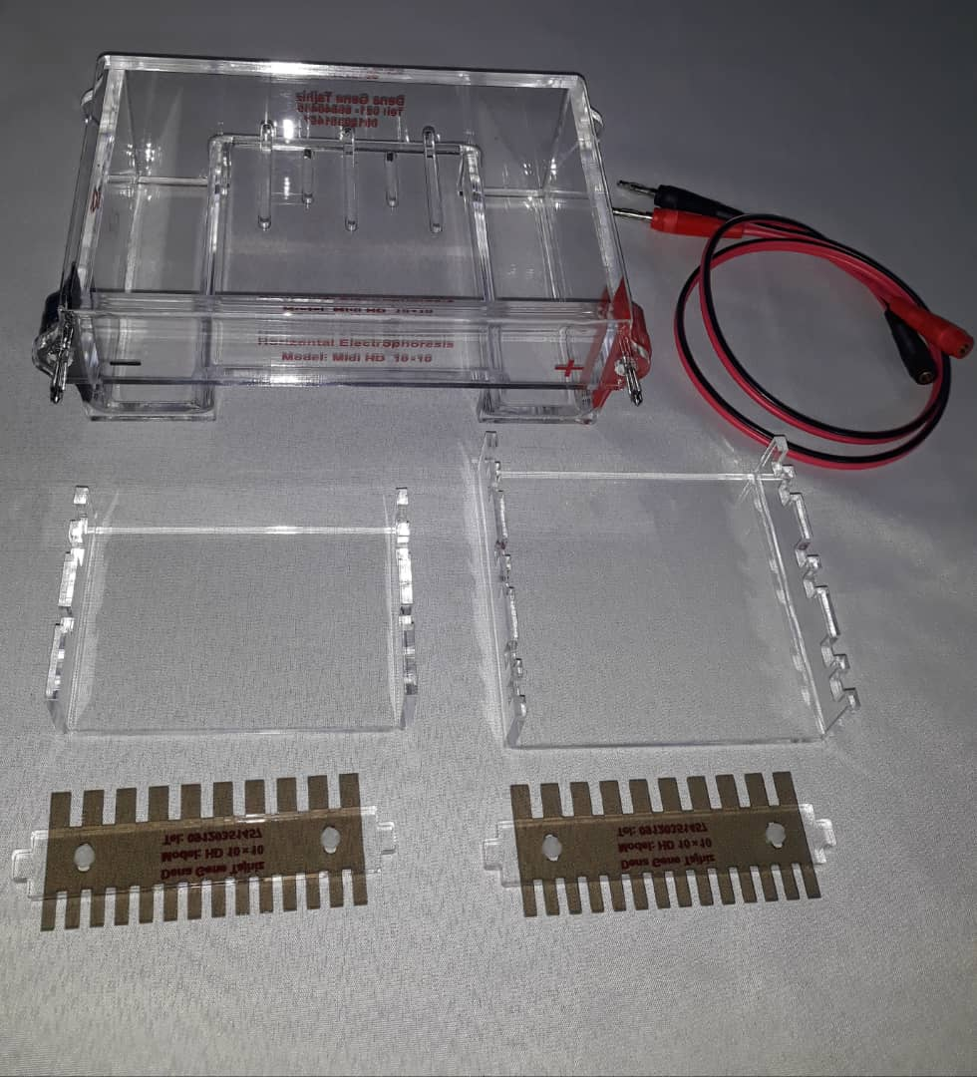

* **Special Comb for Horizontal Electrophoresis Tank:** In the below image, various sizes of combs for horizontal electrophoresis are presented side by side. Each size corresponds to a specific model of the electrophoresis unit.

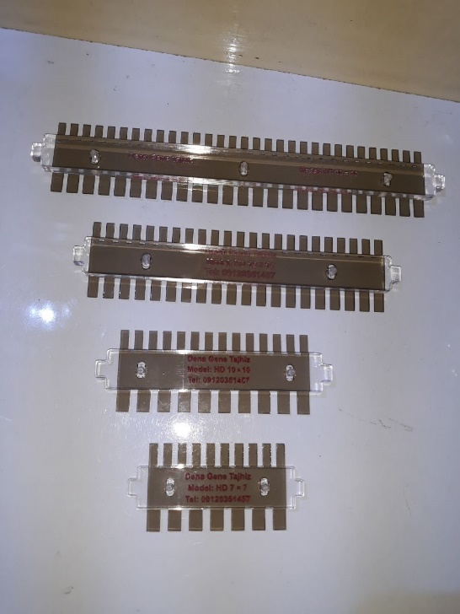

* **Tray**: Each model of horizontal electrophoresis tank has its specific comb and tray. Additionally, the number of combs and trays varies for each electrophoresis unit.
* **Connector Wire for Power Supply Connection**

The table below provides information on the size and quantity of combs and trays for various models of horizontal electrophoresis units:

|  |  |  |
| --- | --- | --- |
| **Tray (Gel Tray)** | **Comb** | **Model** |
| 7x7 | One  7*7 | Mini HD 7x7 |
| 7x10 | Two  10*10 | Midi HD 10x10 |
| 10x10 |
| 10x15 | Two 15*15 | Maxi HD 15x15 |
| 15x15 |
| 10x20 | Three  20*20 | Maxi plus HD 20x20 |
| 15x20 |
| 20x20 |

**Agarose Gel Characteristics:**

Agarose gel is a three-dimensional matrix composed of helical agarose molecules that, when arranged side by side, create three-dimensional pores suitable for the exceptional separation of biomolecules. This three-dimensional structure is formed by hydrogen bonds that can be disrupted by increasing the temperature. The gelation temperature of agarose is significantly different from its melting temperature. Depending on the source, agarose has a gelation temperature between 35-42 degrees Celsius, while its melting temperature is around 85-95 degrees Celsius. Due to the large size of its pores and its high gel strength, agarose gel is highly suitable for electrophoresis of large proteins and DNA. A 1% agarose gel has pores ranging from approximately 100 to 300 nanometers. Low concentrations of agarose gel are very thin, making their movement challenging. Agarose gel, due to the large size of its pores, has lower separation and resolution power compared to acrylamide for DNA; however, its separation range is much broader. The maximum separation range achieved by this type of gel is approximately 750 kilobases, but for separations in the range of 6 Megabase, the PFGE technique is used. This technique is also applicable for separating large proteins and can efficiently separate particles with an effective radius greater than 5-10 nanometers. A 0.9% agarose gel is so large that the T4 bacteriophage can enter it.

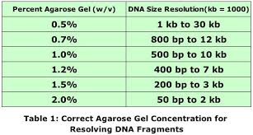

Figure 2. Different Concentrations of Agarose for Separation of DNA Fragments with Varying Sizes

Agarose polymer has a series of negative charges on the sulfate and pyruvate groups. These negatively charged groups, through a process called electroendosmosis (EEO), induce the movement of water flow in the opposite direction to the DNA migration. This phenomenon causes a delay in the movement of DNA molecules and consequently leads to their separation, resulting in weakened bands.

**Factors Influencing Nucleic Acid Migration in the Gel:**

Several factors can influence the migration of nucleic acids: gel pore sizes (gel concentration), DNA fragment sizes, applied voltage, ion strength of the buffer, and the concentration of DNA stain (such as DeNA Gel Stain) if added during electrophoresis. Smaller molecules move faster than larger ones in the gel, and double-stranded DNA migrates at a rate of 1/LOG the number of bases in the gel. However, this relationship does not hold for very long sequences. Increasing gel concentration leads to a reduction in the speed of DNA movement on the gel.

On the other hand, the conformation of DNA can impact its movement on the gel. For example, supercoiled DNA moves faster than relaxed DNA because supercoiled DNA is more compact and therefore moves more easily on the gel. Agarose gel electrophoresis typically indicates the negative supercoiled state of plasmid DNA. However, nicked circular DNA and relaxed circular forms appear as smaller bands.

DeNA Gel Stain, which binds to both strands of DNA, can influence the charge, length, and supercoiled state of DNA molecules, thus affecting the movement of DNA in the gel during electrophoresis. Agarose gel electrophoresis can be used to separate various topological forms of circular DNA with different supercoiling states.

**Anomalous Migration:**

1. Smiley Gel: This phenomenon occurs when the applied voltage for the used gel concentration is excessively high.

2. Overloading of DNA: Excessive loading of DNA leads to slow movement of DNA fragments.

3. Gel Contamination: The presence of impurities such as salts or proteins can affect the migration of DNA.

**DNA Migration and Separation Mechanism:**

The negative charge of the phosphate backbone of DNA molecules causes them to move toward the positive pole (anode). It should be noted that in the absence of a gel matrix, the migration of DNA molecules is independent of their molecular weight and size. Therefore, the role of the gel matrix in DNA separation during electrophoresis is based on size.

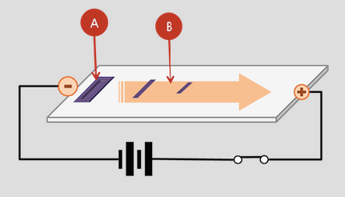

Figure 3) General Overview of Electrophoresis Operation and Direction of Nucleic Acid Movement

**Electrophoresis Procedure**

The horizontal electrophoresis process consists of several consecutive stages, summarized as gel preparation, sample loading, initiation of electrophoresis, and finally, result observation. Each stage is detailed below.

**Preparation of the Gel**

Agarose gel can be obtained by dissolving agarose powder in a suitable buffer, such as TAE or TBE. The agarose powder is first dissolved in the desired buffer and then heated to near boiling temperature, but care should be taken not to boil it. The melted agarose should be cooled before pouring it into the gel tray. If its temperature is too high, the gel tray may become punctured.

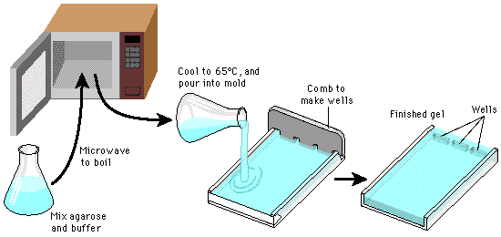

Figure 4: Schematic of Agarose Gel Preparation Stages

**Loading the Samples**

Once the gel is set, remove the comb. Now, by placing it in the tank chamber and pouring in a fresh buffer, you can load the samples sufficiently. It is important to mix the samples with a loading buffer before loading them to facilitate their placement in the wells. Typically, the loading buffer consists of a high-density mixture such as glycerol, sucrose, or Ficoll, which increases the overall density of the samples. This ensures that the DNA samples easily settle at the bottom of the wells. The loading buffer also contains dyes such as xylene cyanol and bromophenol blue. These dyes are used to indicate the progress of the samples on the gel and are referred to as "tracing dyes." Now, load the DNA samples using a loading pipette.

**Initiating Electrophoresis**

Agarose gel electrophoresis is typically run in a horizontal electrophoresis tank, and during the electrophoresis process, the gel is fully immersed in the buffer. It is also possible to perform this type of electrophoresis in a vertical electrophoresis system, but it is less commonly used for agarose gel electrophoresis.

It should be noted that a higher voltage will result in faster separation of samples, but it may lead to gel melting and buffer depletion, resulting in poor sample separation quality. On the other hand, a lower voltage can cause band broadening, especially for small DNA fragments.

Since DNA molecules are not visible to the naked eye, they are loaded with dyes. Xylene cyanol (light blue) migrates with larger DNA molecules, while bromophenol blue (dark blue) migrates with smaller DNA fragments.

During sample loading, a DNA marker is added to a separate well. This marker contains fragments of DNA molecules with predetermined weights, used to estimate the weights of DNA molecules in the samples. It should be noted that the movement of circular DNA molecules (such as plasmids) is different from the movement of linear DNA molecules, and standard markers cannot accurately estimate their weights. Therefore, it is necessary to linearize them using restriction enzymes before running them on the gel.

**Staining and Visualization**

Previously, the common and suitable dye for nucleic acid staining was Ethidium Bromide. This dye, when placed in the large DNA groove, can fluoresce under UV light and be observed using a transilluminator or gel documentation system. Ethidium Bromide can be added before sealing the agarose gel or premixed with the samples before electrophoresis.

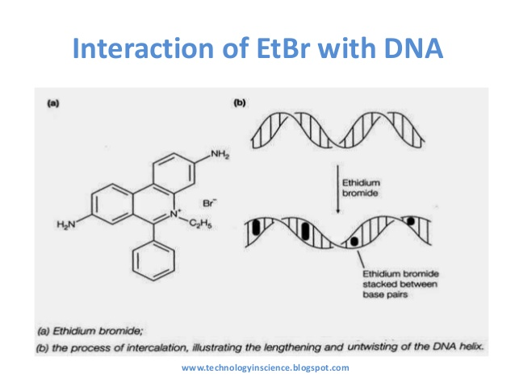

Figure 5. Mechanism of Ethidium Bromide Binding Between Two DNA Strands. Figure (a) depicts the structure of Ethidium Bromide.

However, despite the high-quality staining capability of ethidium bromide, it has been established that this dye has carcinogenic properties. For this reason, nowadays DNA and RNA molecules are typically stained using safe dyes. Dengane Tajhiz Company, for instance, produces a safe dye called "DeNA Gel Stain." This dye is added to the gel as a supplement and can be visualized using various wavelengths (254, 312, and 470 nanometers) on gel documentation systems.

Other dyes that can be used for staining include:

SYBR Green, GelRed, methylene blue, crystal violet, and crystal blue. The Ames test indicates mutagenic (mutation-inducing) capabilities. To observe samples using SYBR Green, a transilluminator with a blue light is required. DNA stained with crystal violet can be observed under normal light without the need for a transilluminator, but this light is not very intense. Typically, transilluminators use wavelengths of 254 and 312 nanometers (UV-B and UV-C), and recently, 470 nanometers. It should always be noted that UV light exposure for 45 seconds can cause DNA damage, affecting subsequent DNA processes such as PCR and transformation. The use of UV devices with longer wavelengths, specifically 365 nanometers (UV-A range), results in less damage to DNA, but commonly used dyes in Iran are not readily visible with this wavelength. The 470-nanometer wavelength minimizes DNA damage, and the routine dyes used in Iran also exhibit high visibility with this wavelength.

Sometimes, it is necessary to use a combination of wavelengths for a process, for example, using a wavelength of 254 nanometers for one operation and 312 nanometers for an extended observation and cutting process. Users need to be aware that the mechanism for the visible and UV wavelengths is not the same and separate transilluminators for each need to be purchased.

**Buffers**

The net charge of biological macromolecules is highly dependent on the pH of the environment. To minimize pH changes caused by the electric field, electrophoresis is typically carried out in a buffered environment. Ideally, the buffer should have high conductivity, generate minimal heat, and have a long shelf life. Some buffers commonly used for agarose gel electrophoresis to separate nucleic acids include Tris-acetate-EDTA (TAE) and Tris-borate-EDTA (TBE). Other buffers are also used, but their usage is much less compared to the two mentioned buffers. Tris buffer has a high buffering capacity, but it cannot be used when DNA extracted in the reaction is sensitive to the phosphate used. TAE buffer has the lowest buffering capacity but exhibits excellent resolution for large DNA molecules. Buffers containing EDTA are often used to inhibit the activity of nucleases that require divalent cations for their function. When separation at the single-base level is required, a gel with 3% agarose and a medium with extremely low conductivity created by 1 mM lithium borate buffer should be used. If buffers are used for an extended period, their buffering capacity may decrease, and they may no longer provide the necessary environment for electrophoresis.

**Applications**

* Estimating the size of DNA molecules after restriction enzyme digestion: For example, mapping cloned DNA after exposure to restriction enzymes.
* Analysis of PCR products: For example, used in genetic diagnostics and genetic fingerprinting.
* Separation of DNA fragments for extraction and purification.
* Separation of digested genomic DNA before Southern blotting or RNA before Northern blotting.

Agarose gels are easily formed and manipulated, and nucleic acids do not undergo any chemical reactions with them. Samples are easily visible in them. After completing the experiment, the obtained gel can be placed in a nylon wrap and stored in the refrigerator.

**Problems with DNA Electrophoresis and Possible Causes**

1. Low Intensity of All or Some DNA Bands

- Possible Reasons:

- Loading a small amount of DNA ladder.

- Insufficient or uneven staining.

- DNA escaping from the gel.

- Infiltration and spreading of DNA in the gel.

- DNA being obscured by dyes used in staining.

2. Smearing of Bands

- Possible Reasons:

- DNA cleavage by nucleases.

- Inappropriate electrophoresis conditions.

- Gel shift effect.

- Overloading of DNA.

- High salt concentration in the sample.

- Improper formation of gel wells.

3. Unusual Band Patterns

- Possible Reasons:

- Failure to denature DNA marker before loading.

- DNA degradation.

- Different loading conditions for sample DNA and marker DNA.

- Inappropriate electrophoresis conditions.

- Incorrect gel percentage or buffer used.

- Unusual migration due to different DNA sequences or structures.

- Gel shift effect.

- High salt concentration in the samples.

4. Curved-Shaped DNA Bands

- Possible Reasons:

- The gel is not entirely in the electrophoresis buffer.

- Low sample volume.

- Inappropriate electrophoresis conditions.

- Bubbles or large particles in the gel wells or the gel itself.

5. DNA Remaining in the Gel

- Possible Reasons:

- Improper well formation.

- Overloading of DNA.

- Contaminated DNA sample.

- Gel shift effect.

6. Determination of Concentration

- Possible Reasons:

- Different loading conditions between DNA marker and samples.

- Use of a marker band for concentration determination.

- Inappropriate quantification method.

- Uneven staining of the gel and background color can affect gel concentration determination results.

- DNA obscured by tracking dyes.

**Documentation and Support**

To obtain support for the latest services and support information for all locations, go to:

[www.Denagene.com](http://www.Denagene.com)

At the website, you can:

• Access worldwide telephone and fax numbers to contact Technical Support and Sales facilities

• Search through frequently asked questions (FAQs)

• Submit a question directly to Technical Support

• Search for user documents, SDSs, vector maps and sequences, application notes, formulations, handbooks, certificates of analysis, citations, and other product support documents

• Obtain information about customer training

• Download software updates and patches

Contact Us:   
[info@denagene.com](mailto:info@denagene.com)