**Denagene Tajhiz Company**

**Biotechnology Lab Equipment manufacturer and designer**

**Blue Light Transilluminator**

**User Guide**

**Blue Light Transilluminator**

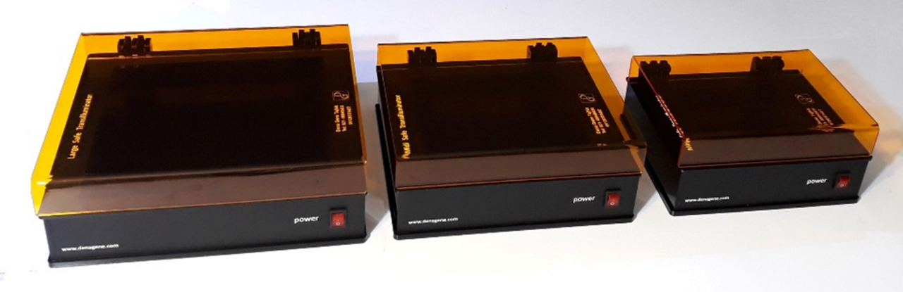

Thanks for choosing the Denagene Tajhiz Company’s Blue Light Transilluminator. This operation manual describes the function of the instrument. To ensure you can correctly operate the instrument, please read the manual carefully before using it. Please keep this manual properly for later use if you encounter any difficulty. The first time opening the packing, please check the instrument and appendix with the packing list. If anything does not match with the packing list, please get in touch with us.

This manual is a valuable resource for all users of our products, whether you are a seasoned professional or just starting your scientific journey. It has been meticulously crafted to ensure that you have a clear understanding of the features, functionality, and proper usage of our laboratory equipment.

Within these pages, you will find detailed instructions, diagrams, and troubleshooting guides that will assist you in harnessing the full potential of our products. We have taken great care to ensure that the content is organized logically, making it easy for you to navigate through the manual and locate the information you need quickly.

Moreover, this manual is a living document that reflects our ongoing commitment to excellence. As we continue to develop and improve our product offerings, we will provide updates and revisions to this manual to ensure that you always have the most up-to-date information at your fingertips.

Reproduction in any form, whether print or electronic, without written permission from Denagene Tajhiz Company, is strictly prohibited.

Content

Introduction

Blue Light Transilluminator

Technical Specification

Safety Instruction

Maintenance

Set up and Installation

Warranty

**Introduction**

After performing electrophoresis, observing the separated bands is crucial for making decisions about the subsequent stages of research. The simplest way to view these bands is by using a transilluminator. Previously, only UV series transilluminators with wavelengths in the UV light range and ethidium bromide were used to observe bands. However, considering the mutagenic nature of UV light and the carcinogenic properties of ethidium bromide, researchers sought a method with equal or even superior efficiency and quality compared to the old methods. Nowadays, dyes with fewer issues and transilluminators with visible and safe light wavelengths are routinely used. Denagene Tajhiz Company, as a leading manufacturer of these devices in Iran, offers them in various models, which will be discussed in more detail below.

**Blue Light Transilluminator**

The dangers associated with UV wavelength transilluminators stem from the high-energy wavelengths of the device, which have the potential to cause harm and illness to the user. Additionally, the use of ethidium bromide dye, which has been proven to be carcinogenic, further prompted researchers to seek alternative methods for observing DNA bands.

**Technical Specification**

|  |  |  |  |
| --- | --- | --- | --- |
| Mini Safe | Midi Safe | Large Safe | Model |
| 12x12 cm | 17x17 cm | 22x22 cm | Filter Size (cm) |
| 20x17x 7 cm | 25x22x7 cm | 30x27x7 cm | Device Dimensions (cm) |
| 470 nm | 470 nm | 470 nm | Wavelength (nm) |
| All except Ethidium bromide | | | Available Dye |

**Safety Instruction**

* Do not keep the device on for more than 5 minutes at a time.
* If there are any scratches or holes on the surface of the device, do not use or attempt to repair it. Instead, immediately contact the repair and after-sales service department of Denagene Tajhiz Company.
* Never handle the device's power cord with wet hands.
* Do not turn on the light source without protective glasses or covering the device.

**Maintenance and Cleaning**

Ensure the device is completely turned off before cleaning. Use a dry cloth or one dampened with water or ethanol to clean the device. Be careful not to use corrosive cleaners or materials that could scratch the surface, as these can cause significant damage to the band observation process and are not covered by the warranty.

**Set up and Installation**

How to Use the Device

1. Ensure there is enough space around the transilluminator for proper air circulation to prevent the device from overheating.

2. To view the electrophoresis results, place the gel on the transilluminator after the electrophoresis process is complete. Ensure the gel size does not exceed the dimensions of the light filter, as any larger areas will not be illuminated by the transilluminator.

3. Once the gel is correctly positioned, turn on the device by pressing the ON button and observe the results.

4. One of the advantages of the Safe View series transilluminator is that its visible and safe wavelength (470 nanometers) poses no harm to the user.

Note: It is important to remember that prolonged and direct exposure to blue light without protection can damage the eyes.

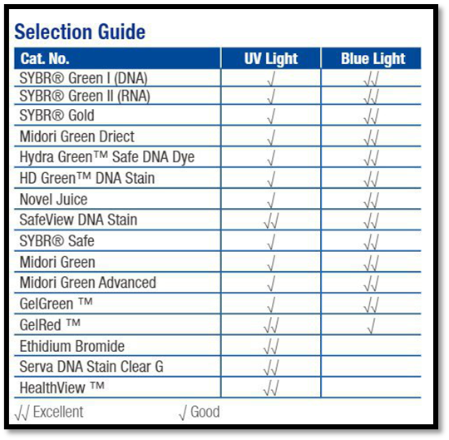

**Table 2. Guide for Using DNA Stain**

Above is a list of stains that can be used for visualization at a wavelength of 470 nanometers with Safe View series transilluminators. As observed, most of these stains are compatible with this series of transilluminators and pose significantly less carcinogenic risk compared to ethidium bromide. Therefore, their use is not only safe in terms of the emitted wavelengths but also because the stains themselves are much safer and healthier. Additionally, Denagene Tajhiz Company produces a DNA stain called DNA Gel Stain, which belongs to the safe stain family and is compatible with both Safe and UV series transilluminators. This stain is added to the gel and can be stored for one year at regular refrigerator temperatures.

**Warranty**

Denagene Tajhiz Company provides a 1-year warranty for all models of the Safe View series transilluminators.

Denagene Tajhiz Company offers 12 years of after-sales service for the transilluminator.

The warranty does not cover breakable items, mechanical and electrical shocks, liquid or chemical spills on electronic systems, or systems opened by unauthorized personnel.

**Documentation and Support**

To obtain support for the latest services and support information for all locations, go to:

www.Denagene.com

At the website, you can:

• Access worldwide telephone and fax numbers to contact Technical Support and Sales facilities

• Search through frequently asked questions (FAQs)

• Submit a question directly to Technical Support

• Search for user documents, SDSs, vector maps and sequences, application notes, formulations, handbooks, certificates of analysis, citations, and other product support documents

• Obtain information about customer training

• Download software updates and patches

Contact Us:

[info@denagene.com](mailto:info@denagene.com)