**Denagene Tajhiz Company**

**Biotechnology Lab Equipment manufacturer and designer**

**Gel Casting**

**User Guide**

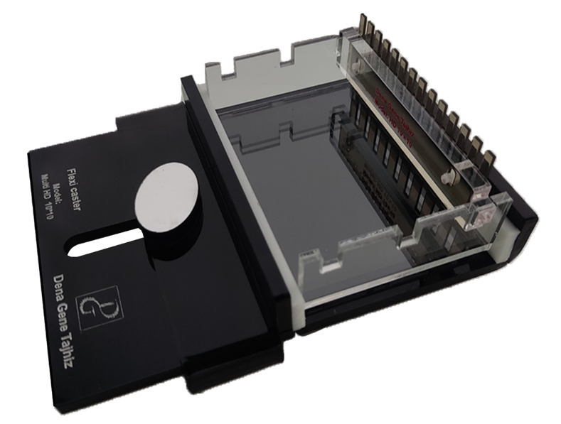 Gel Casting

Thanks for choosing Denagene Tajhiz Gel Casting. This operation manual describes the function of the instrument. To ensure that you can correctly operate the instrument, please read the manual carefully before first using it. Please keep this manual properly for later use if you encounter any difficulty. The first time opening the packing, please check the instrument and appendix with the packing list. If anything does not match with the packing list, please contact us.

This manual serves as a valuable resource for all users of our products, whether you are a seasoned professional or just starting your scientific journey. It has been meticulously crafted to ensure that you have a clear understanding of the features, functionality, and proper usage of our laboratory equipment.

Within these pages, you will find detailed instructions, diagrams, and troubleshooting guides that will assist you in harnessing the full potential of our products. We have taken great care to ensure that the content is organized logically, making it easy for you to navigate through the manual and locate the information you need quickly.

Moreover, this manual is a living document that reflects our ongoing commitment to excellence. As we continue to develop and improve our product offerings, we will provide updates and revisions to this manual to ensure that you always have the most up-to-date information at your fingertips.

Reproduction in any form, whether print or electronic, without written permission from Denagene Tajhiz Company, is strictly prohibited.

Content

Introduction

Warning

Maintenance

Technical Specification

Preparation of the Gel

Possible Issues and Their Solutions

Introduction

Denagene Tajhiz Company has successfully combined molecular and biological engineering sciences by employing skilled and dedicated professionals. This company is a designer and manufacturer of various high-quality molecular biology equipment with superior services. Denagene produces a wide range of equipment related to cellular and molecular research, including various models of horizontal electrophoresis tanks, vertical electrophoresis tanks, western blot tanks, and all their accessories. All esteemed researchers can also order any specific and customized model for their research.

With the remarkable progress that cellular and molecular sciences are undergoing, the demand for this knowledge and its products is increasing day by day in our country. Denagene Tajhiz Company has been able to meet the needs of our hardworking researchers by producing essential products in this field, mitigating our country's reliance on foreign equipment and products, even if only to a small extent.

While thanking you for choosing Denagene Tajhiz Company ‘s gel casting system, it is worth noting that Denagene's electrophoresis tanks, through an in-depth study of the world's reputable manufacturers, have used the finest raw materials to provide the best products to serve our dear country's researchers and specialists. All Denagene products undergo comprehensive quality control and health tests before delivery to customers. It is hoped that, through the production of high-quality products, Denagene can garner the satisfaction of its customers.

Warning:

• Before any use of the apparatus, read and understand the usage instructions.

• Ethidium Bromide is a volatile, mutagenic, and carcinogenic substance. When working with it, use proper protective clothing.

• Typically, a small amount of ethidium Bromide is added to agarose gels before polymerization for nucleic acid staining. It is recommended to use gloves when handling and moving gels.

**Maintenance**

• Clean the apparatus with distilled water only before use, ensuring it is dry.

• Acrylic plastic is not resistant to aromatic compounds, halogenated hydrocarbons, ketones, esters, alcohols (above 25%), and acids (above 25%). These substances can corrode the tank; therefore, it is recommended not to use them for cleaning the device.

• Before use and monthly, check the apparatus for any leaks in connected areas. To do this, wrap the apparatus in a sheet of paper and fill it with distilled water to its maximum capacity. Any leaks will be visible on the paper. If there is any leakage, do not attempt to repair it and inform Dena Gene Equipment as soon as possible.

**Technical Specification**

|  |  |
| --- | --- |
| Name | Gel Casting |
| Model | Multi HD |
| Dimension | 13*19 CM |
| Application | Preparing Horizontal Electrophoresis Gel |
| Models suitable for gel casting | Mini 7*7 , Midi 10*10 |

**Preparation of the Gel**

1. Add a sufficient amount of agarose powder to TBE or TAE buffer.

2. Heat the agarose using a hot plate stirrer or a microwave until it is completely dissolved. If using a microwave, set it to about 400 watts. The solution should be heated until all agarose crystals are dissolved. It is recommended to check for the presence of agarose crystals by looking for suspended particles in the solution. If crystals are visible, it indicates incomplete dissolution, and these particles may interfere with the migration of nucleic acids in the agarose gel later.

Note: The gel should be cooled to between 50 to 60 degrees Celsius before pouring.

3. Install the tray in the gel casting system.

4. Choose the appropriate comb for the user's needs.

5. Pour about 25 to 30 milliliters of agarose solution for a large gel and 12-15 milliliters for a small gel.

6. Place the comb in the slots provided in the gel casting system.

Note: Pour the agarose solution carefully to prevent bubble formation. If any bubbles form, guide them towards the end of the gel before sealing, and disperse them using a pipette tip.

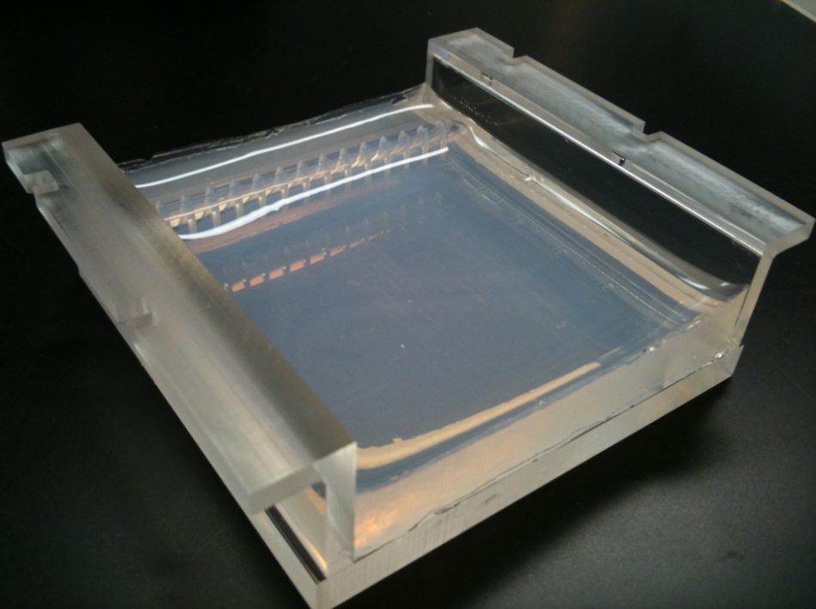

**Possible Issues and Their Solutions**

Issue: Bubbles are not visible when the voltage is applied.

Solution: Ensure the proper functioning of the power supply unit. Check the integrity of the connecting wires. Verify the condition of the electrophoresis system electrodes.

Issue: Electrodes turn gray.

Solution: This is a normal condition and does not affect the performance.

Issue: Agarose solution leaks during gel casting.

Solution: Ensure the cleanliness of the gel casting walls before use. Allow the agarose solution to cool to temperatures between 50-60 degrees Celsius before pouring.

Issue: Gel boils or becomes soft near sample wells.

Solution: This issue is usually due to changes in pH and high temperature. To resolve it, periodically circulate the buffer or reduce the applied voltage.

**Documentation and Support**

To obtain support for the latest services and support information for all locations, go to:

[www.Denagene.com](http://www.Denagene.com)

At the website, you can:

• Access worldwide telephone and fax numbers to contact Technical Support and Sales facilities

• Search through frequently asked questions (FAQs)

• Submit a question directly to Technical Support

• Search for user documents, application notes, formulations, handbooks, certificates of analysis, citations, and other product support documents

• Obtain information about customer training

• Download software updates and patches