Denagene Tajhiz Company

Biotechnology Lab Equipment manufacturer and designer

Mini Centrifuge

User Guide

Mini Centrifuge

Thanks for choosing The Denagene Tajhiz Company’s Mini Centrifuge. This operation manual describes the function of the instrument. To ensure you can correctly operate the instrument, please read the manual carefully before using it. Please keep this manual properly for later use if you encounter any difficulty. The first time opening the packing, please check the instrument and appendix with the packing list. If anything does not match the packing list, don't hesitate to get in touch with us.

This manual is a valuable resource for all users of our products, whether you are a seasoned professional or just starting your scientific journey. It has been meticulously crafted to ensure that you clearly understand the features, functionality, and proper usage of our laboratory equipment.

Within these pages, you will find detailed instructions, diagrams, and troubleshooting guides that will assist you in harnessing the full potential of our products. We have taken great care to ensure that the content is organized logically, making it easy for you to navigate through the manual and locate the information you need quickly.

Moreover, this manual is a living document that reflects our ongoing commitment to excellence. As we continue to develop and improve our product offerings, we will provide updates and revisions to this manual to ensure that you always have the most up-to-date information at your fingertips.

Reproduction in any form, whether print or electronic, without written permission from Denagene Tajhiz Company, is strictly prohibited.

Content

Introduction

Application

Safety Instructions

User Guide

Technical Specifications

Warranty and After-Sales Services

**Introduction**

The Mini Centrifuge-Vortex is a multifunctional device capable of performing several activities simultaneously. The mini-centrifuge is designed in such a way that it can be used even under severe conditions. Simple and user-friendly programming, competitive pricing, durability, and longevity of the device's raw materials are remarkable features of the centrifuge family.

**Application:**

This device is used in various fields of life sciences, especially molecular biology. The mini centrifuge has primary applications in the following research areas:

* Cell culture
* PCR (Polymerase Chain Reaction)
* Genetic Engineering Research
* Nanobiotechnology
* Molecular Biology
* Chemical Engineering
* Many research laboratories

The Mini Centrifuge-Vortex, manufactured by Denagene Tajhiz, with its user-friendly simplicity, reasonable price, and excellent warranty and after-sales service conditions, is an outstanding option for use by researchers and users alike.

**Safety Instruction:**

1. Place the device on a balanced and flat surface.

2. Before placing samples for mixing, make sure that the sample lids are securely closed.

3. Do not use the apparatus in high-humidity environments.

4. Connect the apparatus to a power source with the appropriate voltage.

5. Disconnect the apparatus from the power source completely before moving or relocating.

6. Protect the apparatus from shaking and falling.

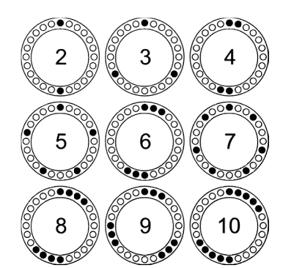

Figure 1. Proper Loading Procedure of the Mini Centrifuge

Usage Instructions:

1. Begin by unpacking the device.

2. Place the apparatus on a balanced and level surface.

3. Connect the power cable located at the back of the apparatus to a power source.

4. Press the power button to turn on the apparatus's user panel.

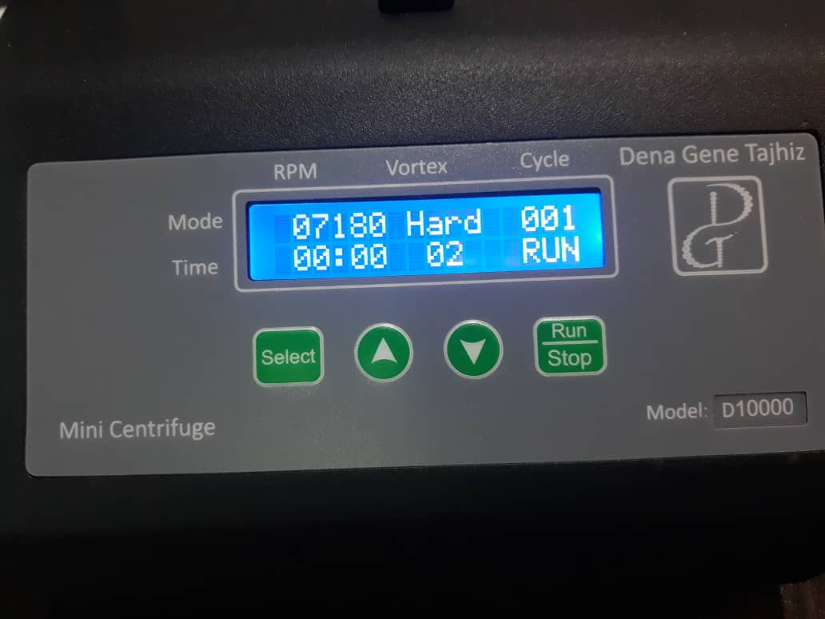

Figure 2. User Panel of the Apparatus During Operation

Now, for precise parameter adjustment, press the Select button. The apparatus will automatically start blinking on the RPM mode. By defining the RPM value using the Up and Down buttons, press the Select button again. Now, the setting mode is on the Vortex mode. Vortex has three modes: Soft, Medium, and Hard. Using the Up and Down buttons, the user can adjust to any of these modes based on their needs. Now, it's time to set the number of cycles that the apparatus will repeat for both centrifuge and vortex. Use the Up and Down buttons to set the desired cycle. Press the Select button again to enter the time setting mode for the centrifuge. Here, the time is adjustable in minutes and hours, with the Up and Down buttons adjusting the required time. Pressing the Select button again enters the time setting system for the vortex. In vortex mode, the time is adjustable in seconds, with a maximum time of 30 seconds. Finally, after setting all parameters, press the Run/Stop button to start the device. If the user wants to stop the device while it is running, press and hold the Run/Stop button for 2 seconds.

Note: If the device's lid is opened during operation, a "lid open error" will be displayed, and the device will stop working.

Note: If the user defines the centrifuge and vortex modes but does not define the cycle, the apparatus will only perform centrifugation. Therefore, the user must define at least one cycle to perform both centrifugation and vortex.

Note: Selecting a completely flat and sturdy surface for centrifugation and vortex operations, as well as the overall lifespan of the apparatus, is crucial.

**Technical Specifications**

|  |  |  |
| --- | --- | --- |
| **D 6000** | **D 10000** | **Model** |
| 6000 RPM | 10000 RPM | Maximum Speed |
| 1700 | 4700 | Maximum Centrifugal Force (g-Force) |
| 1.5 &2 | 1.5 &2 | Capacity |
| 0.5 | 0.5 |
| 0.2 | 0.2 |
| 20x15x14 cm | 20x15x14 cm | External Dimensions |
| 220 V | 220 V | Voltage |
| 4.5 Kg | 4.5 Kg | Weight |

**Warranty and After-Sales Services:**

* Denagene Tajhiz company provides a one-year warranty for all models of the mini centrifuge.
* The Mini Centrifuge device, manufactured by Denagene Tajhiz Company, is backed by 10 years of after-sales services.

**Documentation and Support**

To obtain support for the latest services and support information for all locations, go to:

[www.Denagene.com](http://www.Denagene.com)

At the website, you can:

• Access worldwide telephone and fax numbers to contact Technical Support and Sales facilities

• Search through frequently asked questions (FAQs)

• Submit a question directly to Technical Support

• Search for user documents, SDSs, vector maps and sequences, application notes, formulations, handbooks, certificates of analysis, citations, and other product support documents

• Obtain information about customer training

• Download software updates and patches

Contact Us:

[info@denagene.com](mailto:info@denagene.com)‌